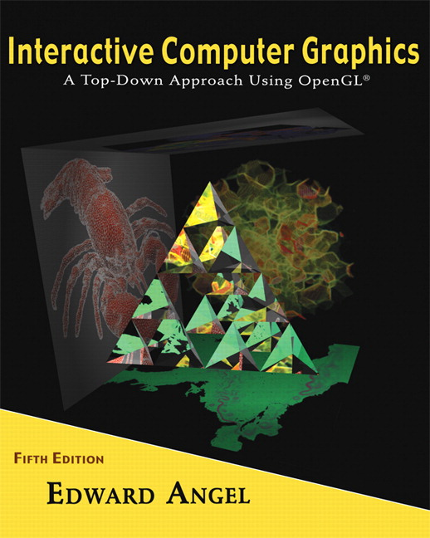 COSC 4370
Name: ____________________ TERMINAL # ____
Programming Assignment 3 Acceptance Testing:

After you downloaded your zipped project from BB and rebuilt it using the 200 PGH Visual Studio 2010, take screenshots of the output produced, and insert it in this file ……..
Lighting and Shading:
1. Place spot light at top front right initial direction towards the center of the JURASIC PARK.
SCREENSHOT Output of your program is:
……..

2. Move light at top front left.
SCREENSHOT Output of your program is:
……..

3. Move light at top back right.
SCREENSHOT Output of your program is:
……..

4. Move light at top back left.
SCREENSHOT Output of your program is:
……..

5. Place spot light at top front right initial direction towards the center of the JURASIC PARK angle of the light to 90.
SCREENSHOT Output of your program is:
……..

6. Place spot light at top front right initial direction towards the center of the JURASIC PARK angle of the light to 45.
SCREENSHOT Output of your program is:
……..

Texturing:
1. Texture your JURASIC PARK by using either a texture similar to the actual JURASIC PARK or any other JURASIC PARK siding textures or bump mapping.
SCREENSHOT Output of your program is:
……..

2. If you have several texturing, create a menu main textures option to use all of them. I guess this could be the extra credit problem. (20 points)
SCREENSHOT Output of your program is:
……..

Text on the SPHERE:
1. SCREENSHOT Output of your program is:
……..

Source Code:
1. Copy and Paste your .c (.cpp) file here:
…….

When done attach this file to “Testing Programming Assignment 3” BB assignment.

